Category | Product | Image | Change
Shot Pin | UB2  UB4 | 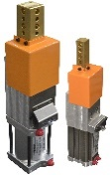 | No changes
 | SB4  SB6 | 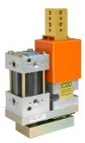 | No changes
 | WP4  WP6 | 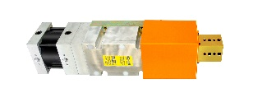 | No changes
 | DB2  DB4  (aka Guided Slides) | 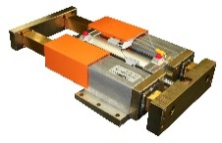 | No changes
 | HP5 Bull Pin | 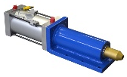 | New handwheel option for manual operation
Part Ejectors | UPE  SPE  MPE | 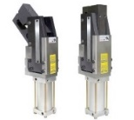 | No changes
Part Positioners | LST  SST  MST | 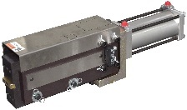 | No changes
Pneumatic Slides | P5 | 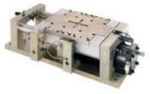 | No changes
 | R2 | 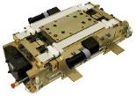 | No changes
 | NL3  WL3 | 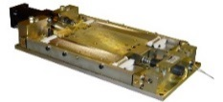 | No changes
 | LP1  LP2  LPM - NEW! | 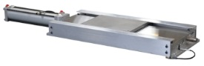 | New LPM mini slide added to LP series
 | Smart Stop | 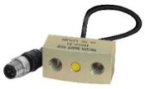 | No changes
Part Presentation Slides | AES | 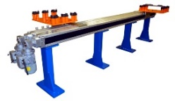 | No changes
Compact Lifters | CLM40  CLM50 | 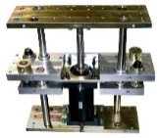 | No changes
Ground Blocks | GB3, GB2  S02645 | 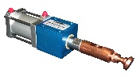 | No changes
 | GBS | 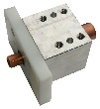 | Formerly part number S03013
 | GBP - NEW! | 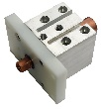 | New pass-thru pneumatic ground block
 | GBM - NEW! | 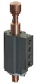 | New pass-thru spring ground block
Lockout Pins | BP2  BP4 | 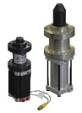 | No changes
 | DS3 | 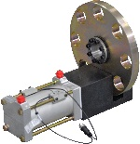 | No changes
Pallet Stop | CMX | 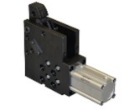 | No changes
Floating Pins | FP2  FP4 | 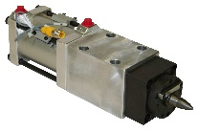 | No changes

Category | Product | Image | Change
Pin Clamps | PCS  PCT  PCM | 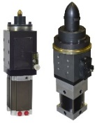 | No changes
 | PCY | 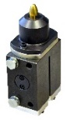 | No changes
 | PCZ | 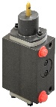 | No changes
Clamps | Tube Clamps | 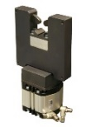 | No changes
 | Wire Clamps | 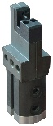 | TCA is new wire clamp part number  S01728 and S02128 will be moved to Service Parts 1/1/22
 | Hook Clamp | 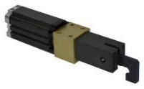 | No changes
Mini Locating Pins | MPS  MPC | 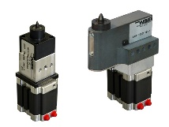 | No changes
 | RMP | 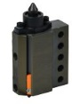 | No changes
 | RTP | 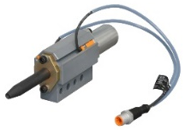 | No changes
 | NMP | 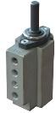 | No changes
Auto-Index Dimpler | WD3 | 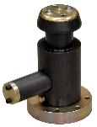 | No changes

Service Parts List
Legacy parts are only available as service parts: replacements on existing tooling. Contact Welker for pricing and delivery lead time.
Category | Product prefix | Recommended replacement*
Shot pins | RS4
 | UR3
 | WSPP
 | WSPM
 | WPA
 | SB2 | UB2
 | WP2 | UB2
Lockouts | BRP | BP4
 | FRP
 | MRP
 | MMS
 | SRP
Slides | CS1 | LP1, LPM
 | CS2 | LP1, LPM
Lifter | CLA | CLM
Wire Clamps | S01728, S02128 | TCA (available 2/1/22)

*Recommended replacement units are not direct swap-outs for legacy parts.

